**Assignment 1.3**

Write a Python program to accept the user's first and last name and then getting them

Printed in the reverse order with a space between first name and last name.

**Method: 1**

First_name = input(" Enter First Name : ")

Last_name = input(" Enter Last Name : ")

print ("Hello " + last_name + " " + first_name)

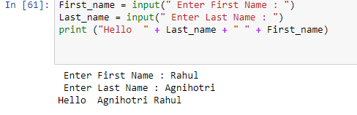

**Method: 2**

First_name = input(" Enter First Name : ")

Last_name = input(" Enter Last Name : ")

print("%s %s"%(last, name))

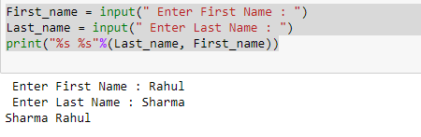

**Method: 3**

full_name = input("Enter your full name : ")

print("Hello "+" ".join(reversed(full_name.split(" "))))

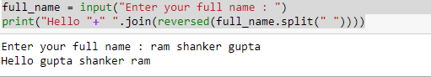

**Method: 4**

full_name = input("Enter full name : ")

print("Hello "+" ".join(reversed(full_name)))

